Wasdom Esp32 algorithm

1. Download Arduino ide
2. Open the program and go to file>preferences> then add this link(https://dl.espressif.com/dl/package_esp32_index.json )to the additional board manger URLs, and press OK

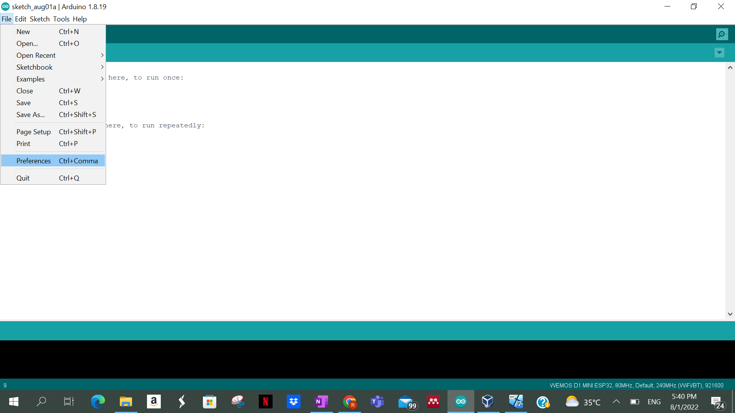

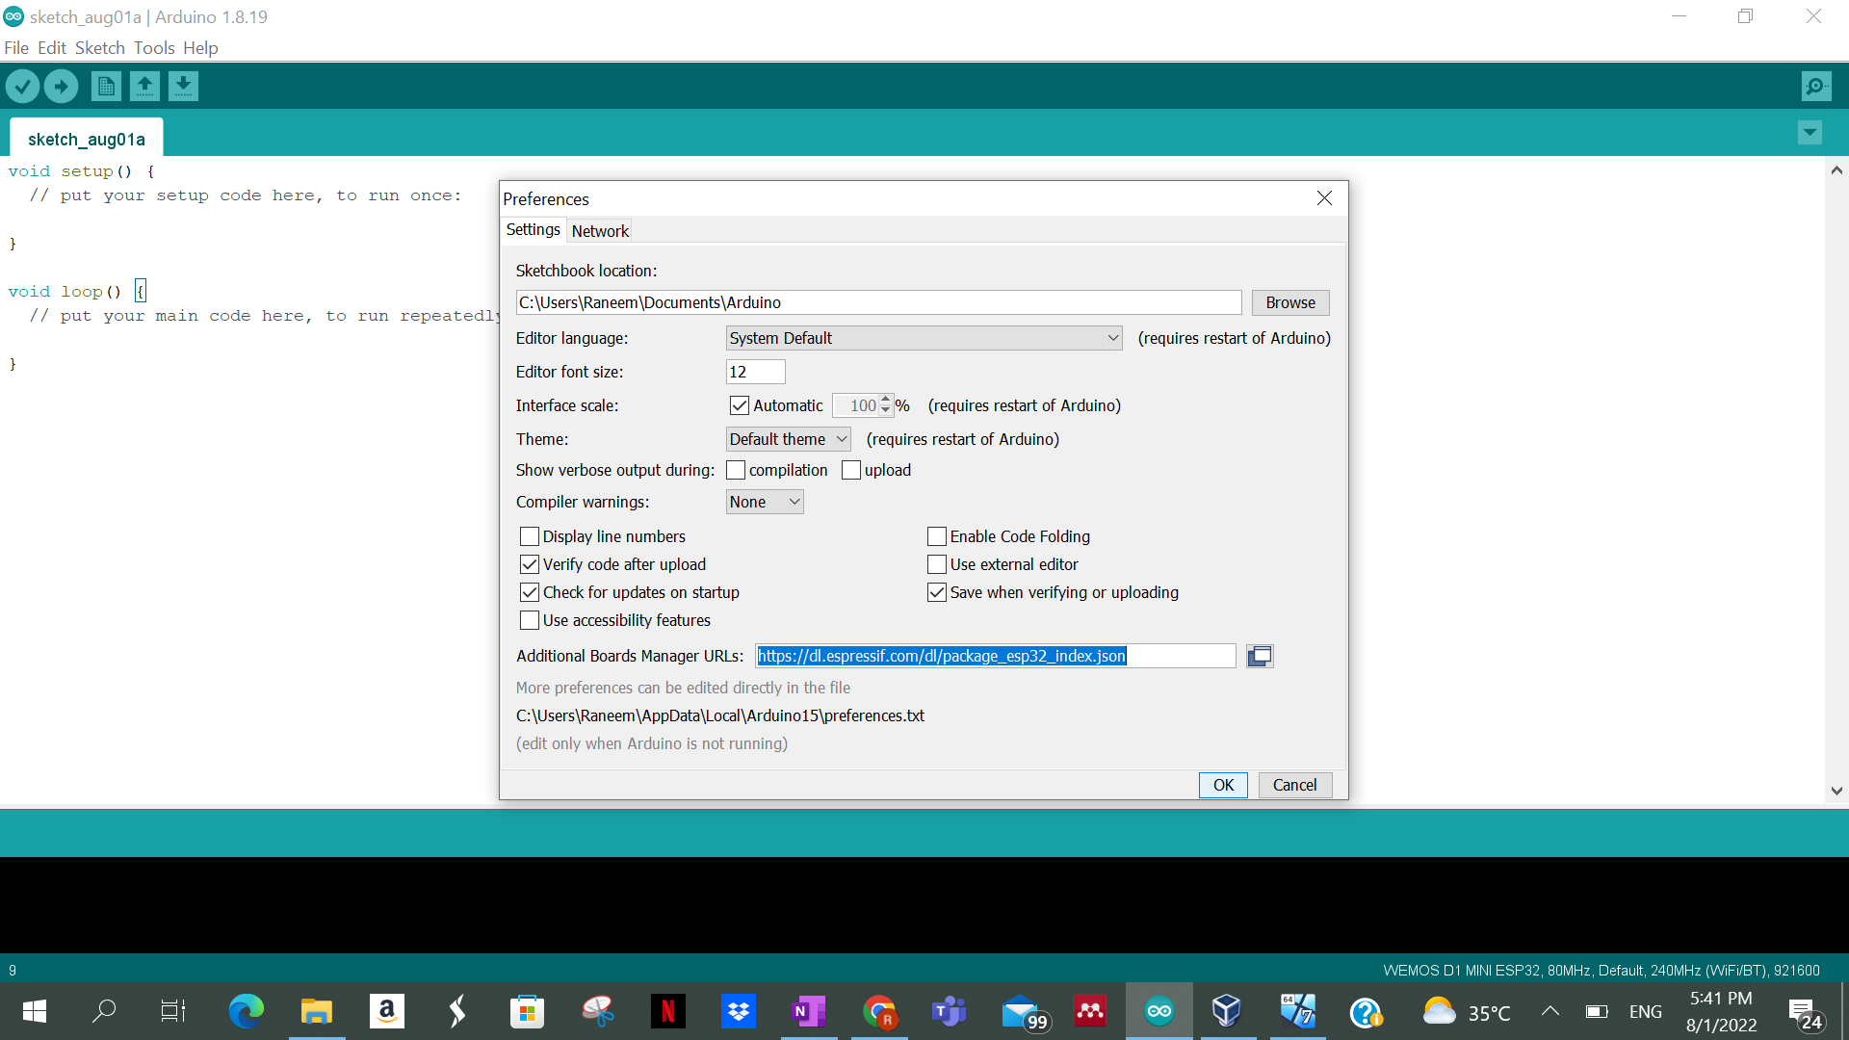

1. Go for Tools > Board Manger and search for ESP32 library and download it

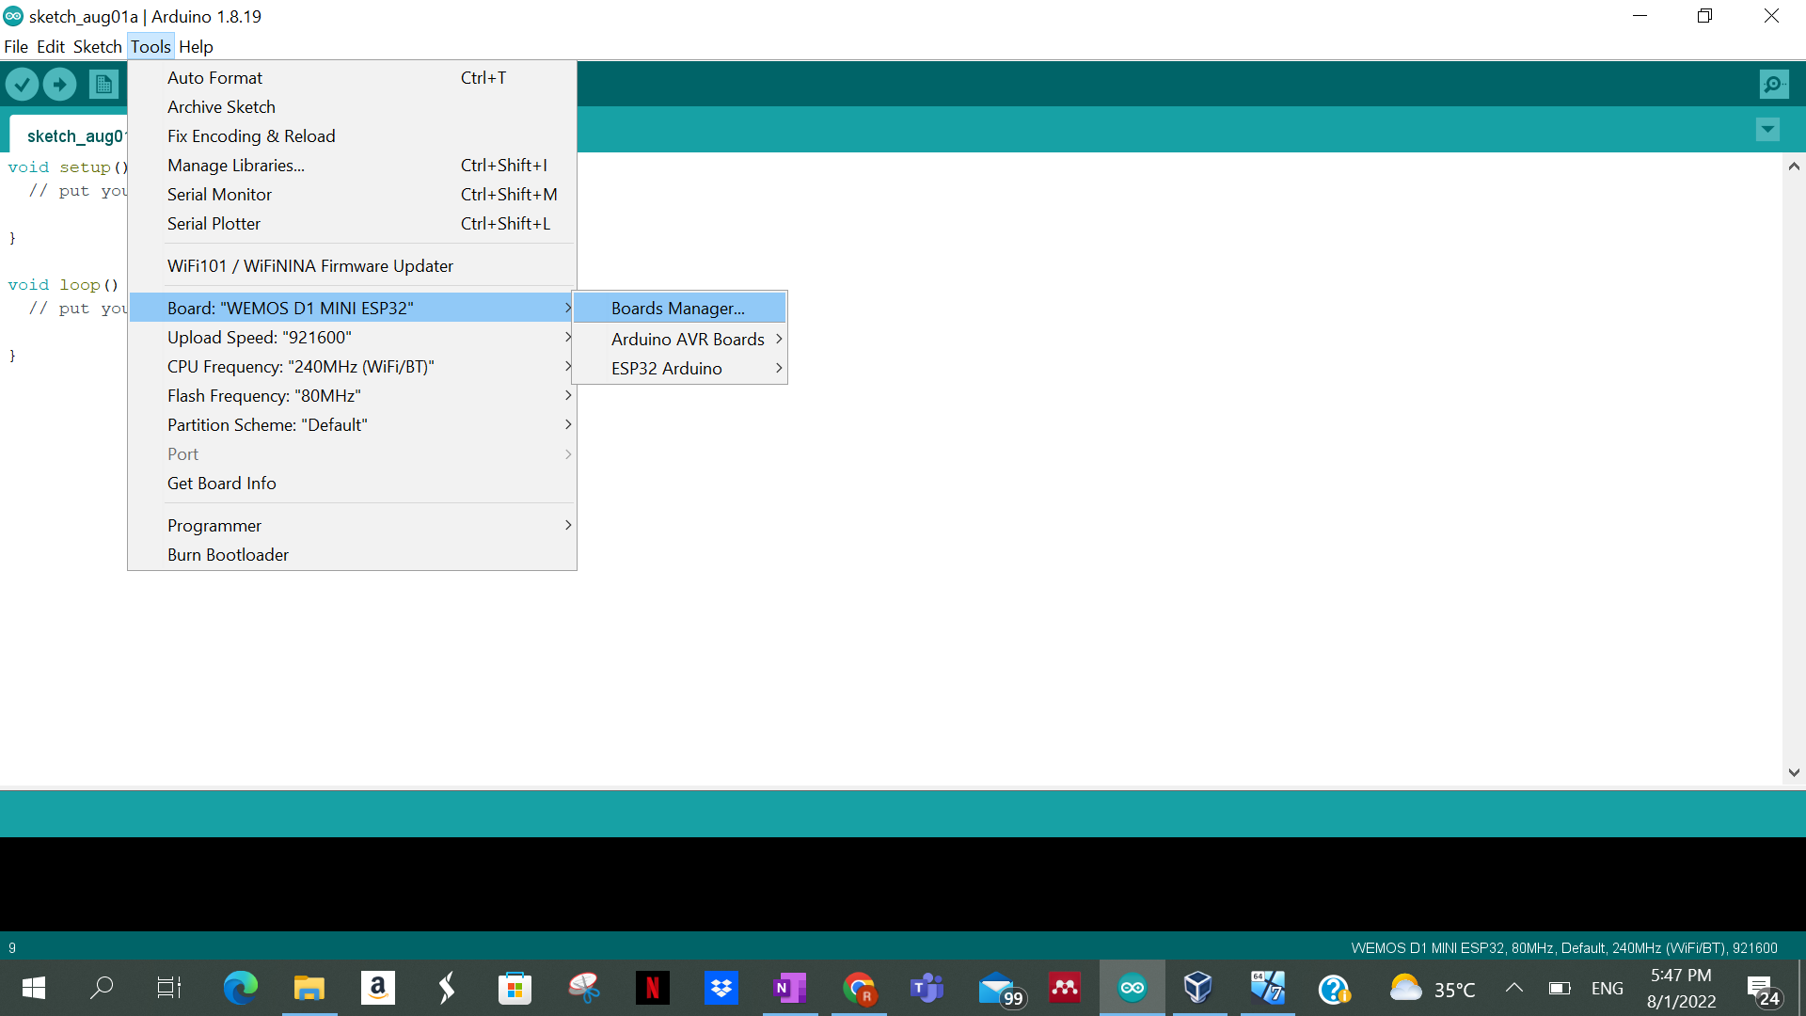

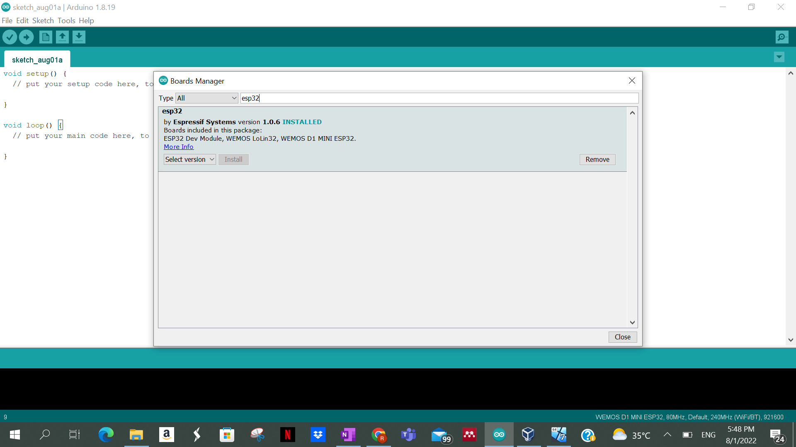

1. Go for Tools > Board and choose WEMOS D1 MINI ESP32 from ESP32 Arduino

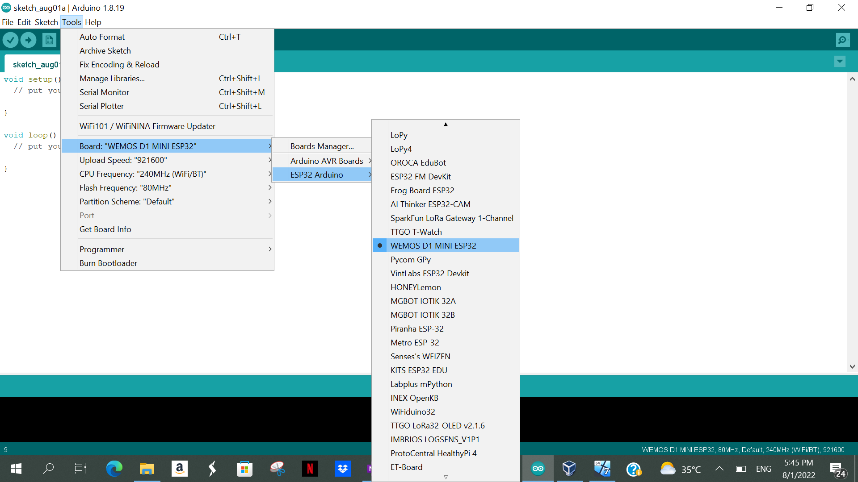

1. Connect the board to your device and choose the port from Tools > Port

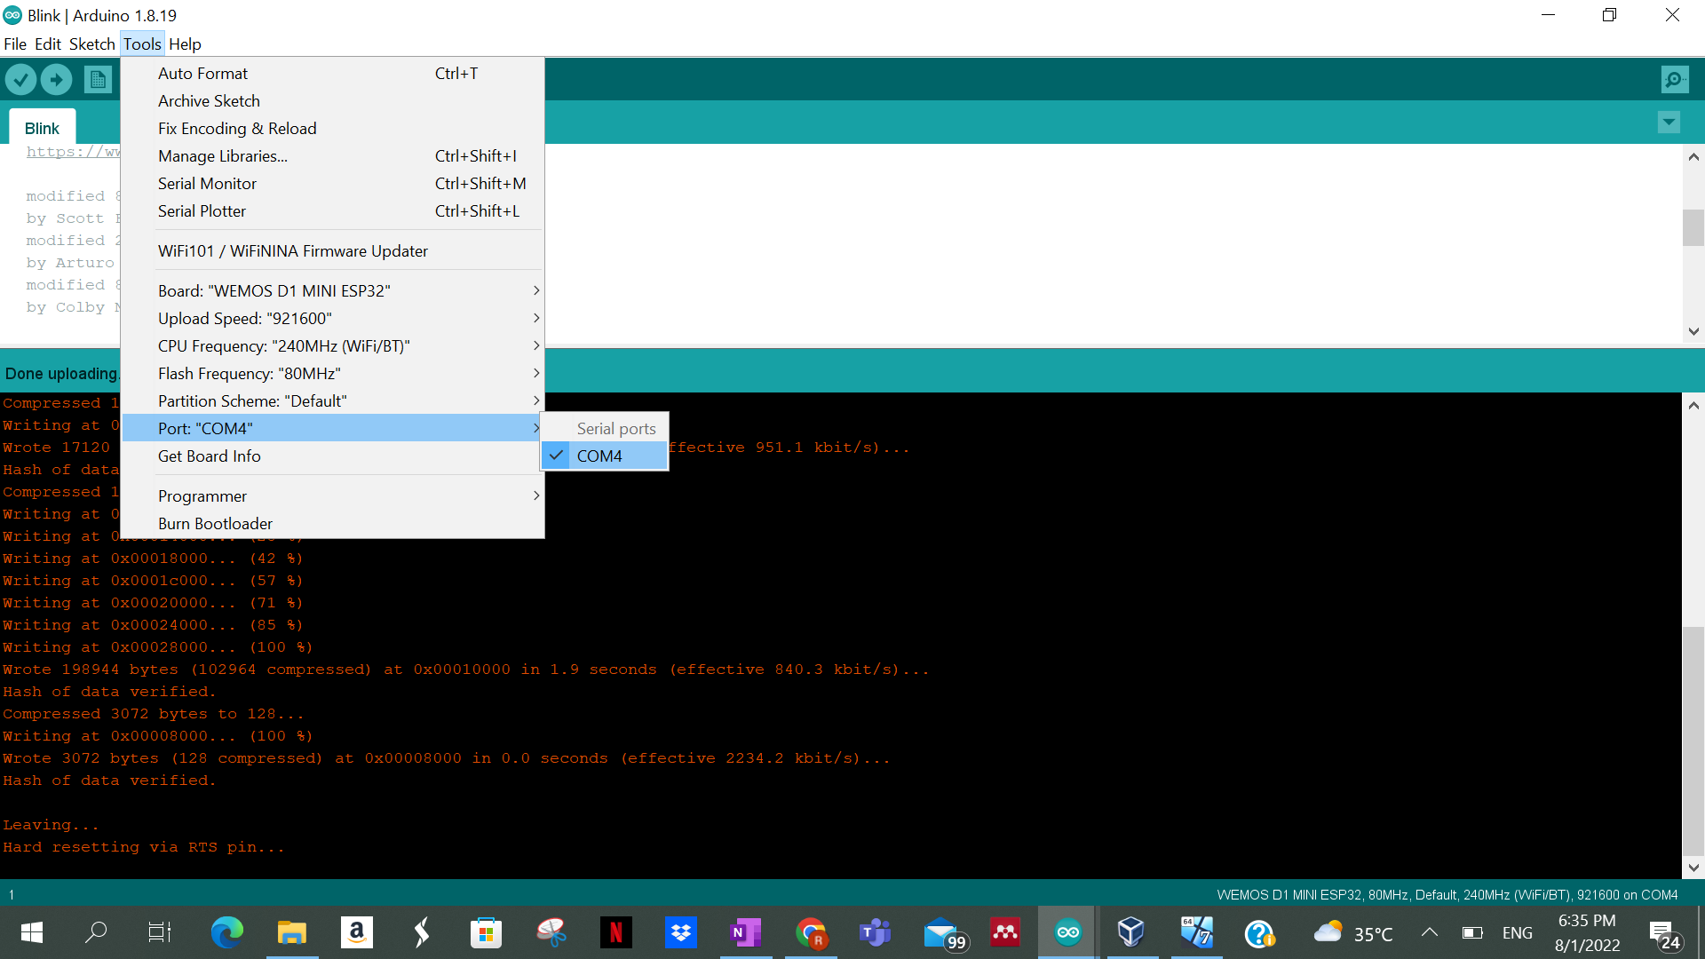

1. Go for File > Example > 0.1 Basics > Blink

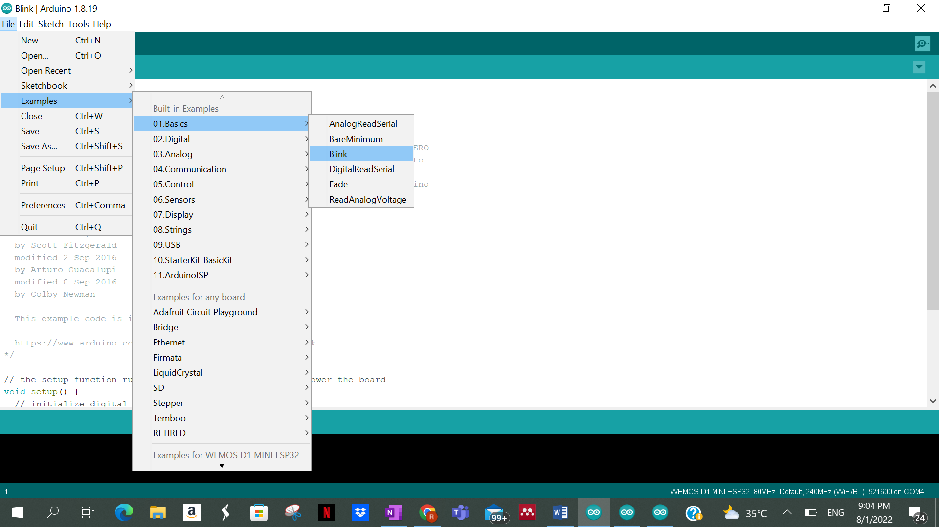

1. Now upload the code and run it

*/

// the setup function runs once when you press reset or power the board

void setup() {

// initialize digital pin LED_BUILTIN as an output.

pinMode(LED_BUILTIN, OUTPUT);

}

// the loop function runs over and over again forever

void loop() {

digitalWrite(LED_BUILTIN, HIGH); // turn the LED on (HIGH is the voltage level)

delay(1000); // wait for a second

digitalWrite(LED_BUILTIN, LOW); // turn the LED off by making the voltage LOW

delay(1000); // wait for a second

